Linux is a multi-user operating system where multiple users can access system resources simultaneously. Proper user and group management is essential to ensure system security, controlled access to files, and efficient administration. Cyber security professionals must understand how Linux manages users, groups, ownership, and permissions to prevent unauthorized access and enforce security policies.
The problem is to create, modify, and manage users and groups in Linux, understand file ownership and group permissions, and practice sharing files securely between users and groups.

Theory

Users in Linux
Each user in Linux has:
- A unique username
- A user ID (UID)
- A home directory
- A default shell
Linux supports different types of users:
- Root user – Superuser with full system privileges
- Normal users – Regular users with limited privileges

Groups in Linux
Groups are collections of users that simplify permission management. Each file or directory belongs to:
- One owner
- One group

File Ownership
Ownership determines who can read, write, or execute files. The commands chown and chgrp are used to modify ownership.

Sticky Bit
The sticky bit is a special permission that prevents users from deleting files owned by others in a shared directory.
Example:
chmod +t directory_name

Commands Used
useradd | Create a new user
passwd | Set or change user password
usermod | Modify user account
userdel | Delete a user
groupadd | Create a new group
groupdel | Delete a group
groups | Display groups of a user
chown | Change file owner
chgrp | Change file group
chmod | Change permissions
id | Display user identity

Procedure
Log in to the Linux system.
Open the terminal. Create a new user:
sudo useradd testuser sudo passwd testuser
Verify the user:
id testuser
Create a new group:
sudo groupadd testgroup
Add user to the group:
sudo usermod -aG testgroup testuser
Check user group membership:
groups testuser
Create a shared directory:
mkdir shared_dir sudo chgrp testgroup shared_dir sudo chmod 770 shared_dir
Apply sticky bit:
sudo chmod +t shared_dir
Change file ownership:
sudo chown testuser:testgroup shared_file.txt

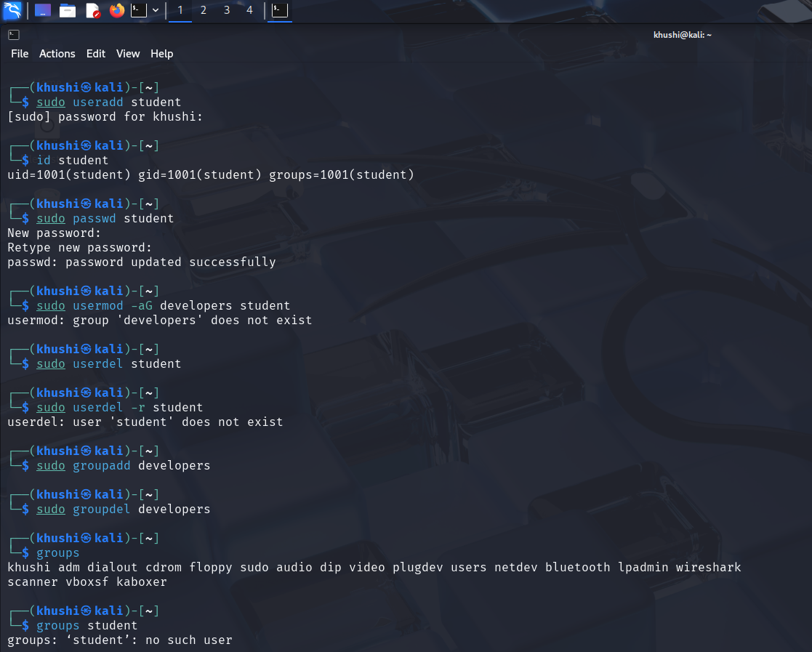
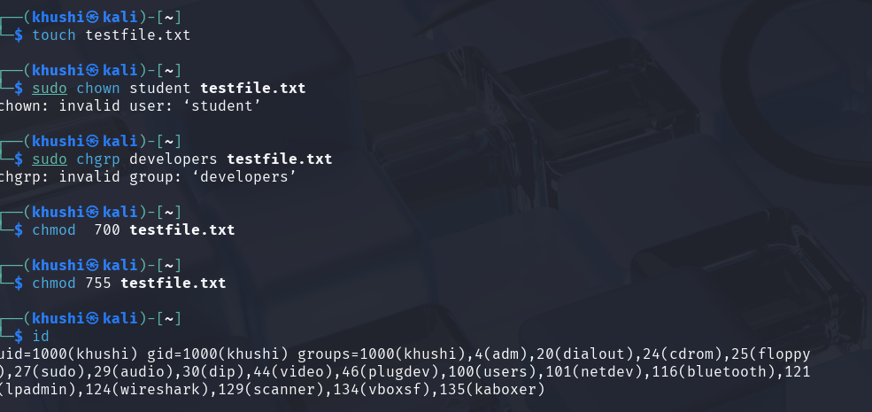

Result
Linux user and group management operations were successfully performed. The student learned to control access to system resources using users, groups, permissions, and special access bits.

